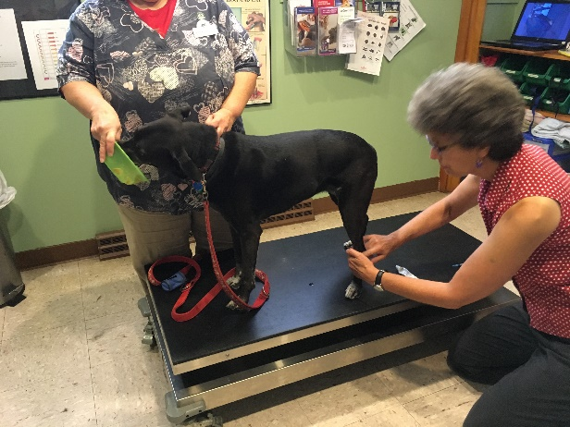
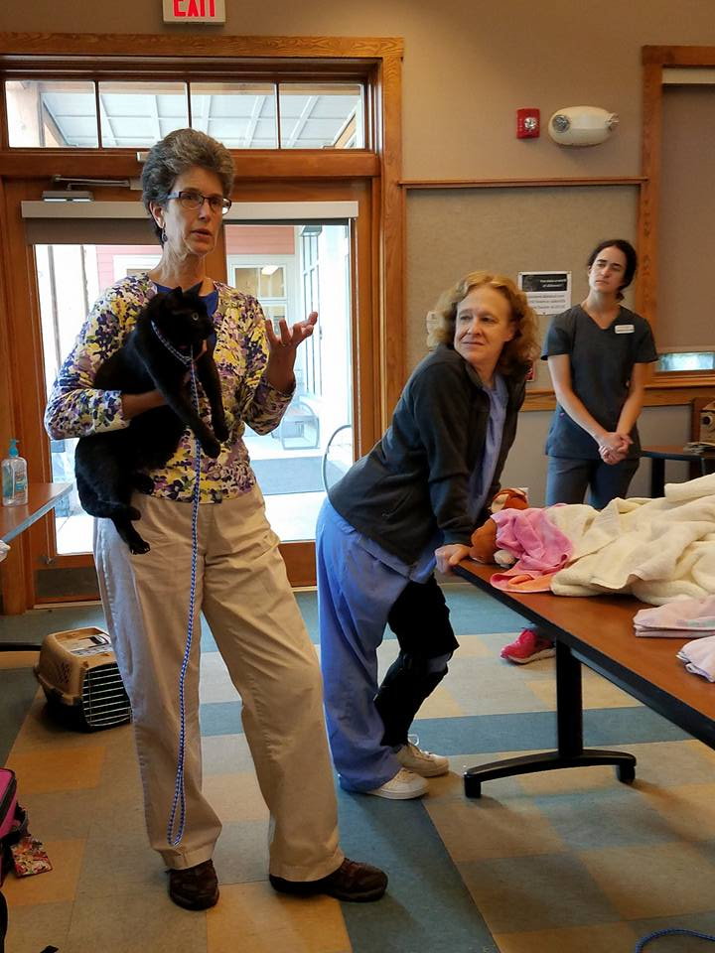
Staff Training at your clinic,
Figure 1anxious safe blood draw techniques to use daily for safe low stress care
Figure 2Dr. Foote leads a hands on immersion workshop at the ASPCA - Asheviile on site
at Bella Behavior Learning Center,
or on-line
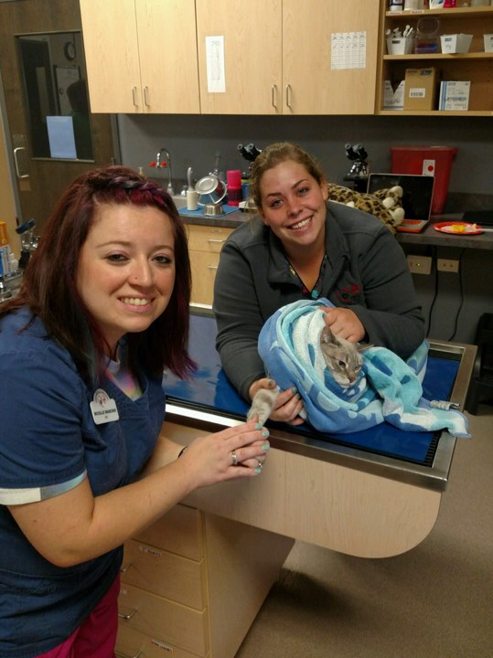
Figure 3 Nicolle Marchio CVT teaches her staff after an immersion workshop at the learning center
Improve your staff’s ability to handle anxious, aggressive, and aging dogs and cats safely in a Low Stress manner.

On Site – one on one sessions at your clinic, with 1 year support. All presentations, handouts, and protocols provided to implement techniques, customized to your practice. Contact at dr.sally@mchsi.com for a quote

Immersion seminar days Feline Immersion, and Essential of Low Stress Handling dog and cat 7 hours of presentation and handling lab in a model veterinary practice. 1 year support
$600/pp 9 hours RACE CE 2 day immersive 21 hours RACE CE with additional aggressive handling wet lab $1500/pp – great for head techs to train staff at the clinic. https://www.drsallyjfoote.com/veterinary-professional/clinic-consultation-and-staff-training/
On demand courses – 1 to7 hour RACE Ce Topics in essential and advanced Low Stress Veterinary Care, Puppy Behavior certification and more. Starting at $44.95/course RACE approved –
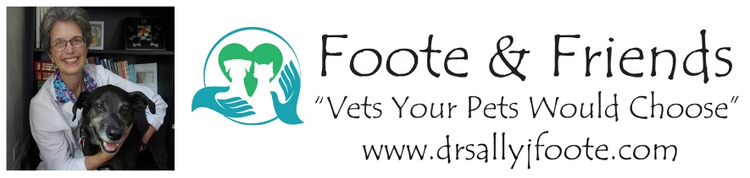
https://www.drsallyjfoote.com/shop/

Contact – dr.sally@mchsi.com phone 217-722-4484

